Assignment 2
Topic: Hospital Record Code and 2 Vector Codes

Name: Soham Ajit Puri
Roll. No: 04
Branch: CSDS_C1

- Vector Code using pushback:
This program demonstrates the use of the push_back() function with C++ vectors. The goal is to store marks of students dynamically without knowing in advance how many students will be there.
The user first enters the number of students, then the program:
- Accepts each student’s marks using push_back() to add them to a vector<int>.
- Displays all the entered marks.
- Calculates and shows the average marks.
The key benefit here is that vectors handle dynamic resizing automatically, unlike arrays where the size must be fixed in advance. This makes it perfect for storing data when the size can vary.
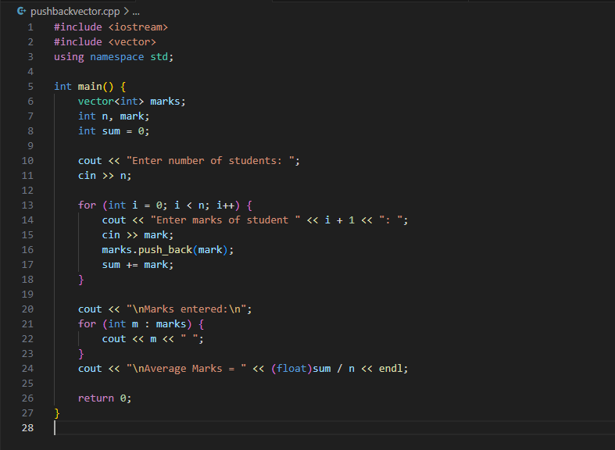
CODE:

OUTPUT:

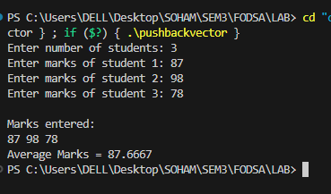

- Grocery Store Inventory Tracker:
Purpose:
To manage a small grocery store’s inventory by storing details of each item (name, quantity, and price per unit), displaying them in a clear table, and calculating the total stock value.
How it Works:
- The program asks the user for the number of items.
- For each item, the user enters the name, quantity, and price per unit.
- All items are stored in a vector of structures.
- The program displays the inventory in a tabular format showing the total value for each item.
- It calculates and displays the grand total value of all stock.

CODE :
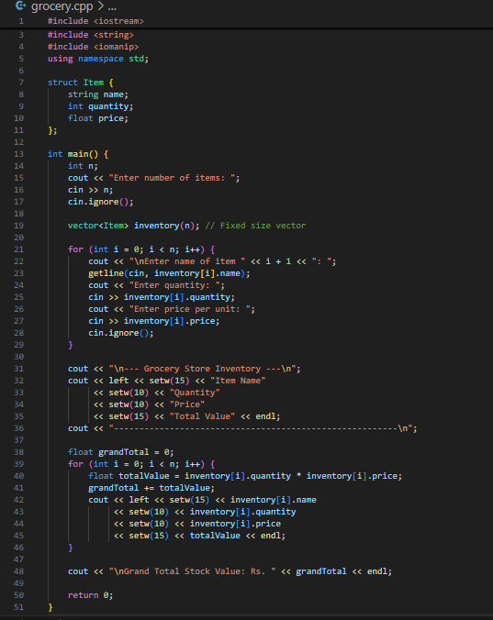

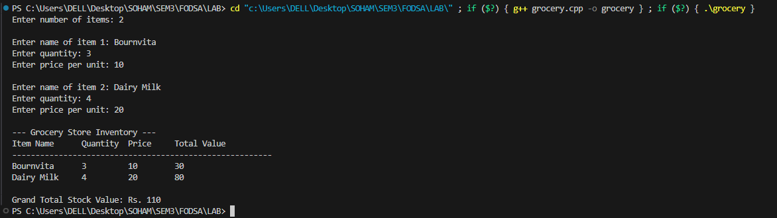
OUTPUT:

- Hospital Records Using Sparse Matrix:
To track hospital bed availability using a sparse matrix representation. This approach stores only the information about occupied beds rather than storing the status of every bed, saving memory and improving efficiency when the hospital has many empty beds.

How it Works:
- This hospital ward layout is considered as a 2D grid (rows × columns) where each cell represents a bed.
- Instead of storing all beds, the program only records the row and column positions of occupied beds.
- A vector<vector<int>> is used where:
  - beds[i][0] stores the row number.
  - beds[i][1] stores the column number.
- The user enters the total number of beds occupied and their positions in the ward.
- The program displays a sparse matrix representation along with a full layout for better visualization.
- This saves memory when the ward is large but has fewer patients.
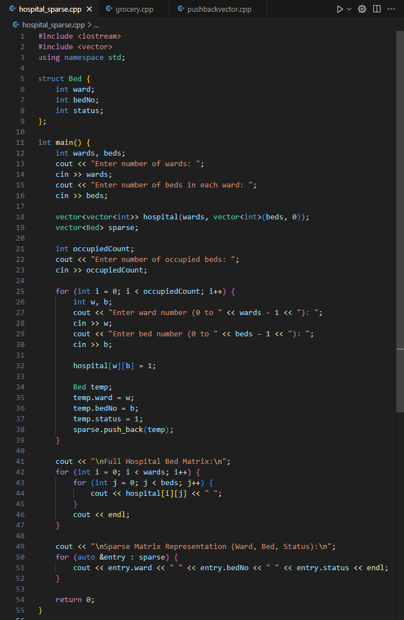
CODE:

OUTPUT:

